Colton Mouritsen Andrew ID: cmourits

Alex Caico Andrew ID: acaico

Nicolas Wells Andrew ID: nwells

**Final Paper**

95-891 - Introduction to Artificial Intelligence

Predicting Housing Prices

**Problem Statement** **2**

**Data** **2**

Exploratory Data Analysis 3

**Approach** **4**

How are others solving this problem? 4

What methods did we consider to solve the problem? 4

Data Cleaning 5

Data Imputation 5

Removing Outliers 5

Standardizing 5

Feature Engineering 5

Clustering on Location 5

Transforming Images 6

Text Analysis 7

Model Creation 7

Baseline Model (Linear Regression) with Numerical Features Only 7

Multi-Layer Perceptron (MLP) with Numerical Features Only 7

Convolutional Neural Net (CNN) with Images Only 8

Long-Short Term Memory (LSTM) with Text Descriptions Only 11

Mixed -Type Multi-Input Neural Network with all feature types 12

**Results** **12**

Model Performance 12

A Personal Test 13

How can we improve? 15

What did we learn? 15

**Appendix** **16**

Appendix A - Links to Google Colab .ipynb Files 16

Appendix B - Clustering locations with latitude and longitude 16

Appendix C - CNN Model Architecture 17

Appendix D - Combined Neural Net Architecture 18

Appendix E - Team Member Assignments 19

## Problem Statement

When a person wants to sell their home, it’s often difficult to know how to set the price. Our objective is to optimize the home selling process by predicting a home’s value. The process of prediction takes into account three different types of data and trains models for each type. The data types are as follows:

1. Numerical/Categorical Listing Features: number of bedrooms, bathrooms, rooms, square footage, acreage, year built, and location (estimated neighborhood based on cluster).
2. Text Description: Each listing contains a description provided by the listing creator.
3. Images: Listings have photos that can help potential buyers visualize the homes.

Each of these data types are incorporated into a separate neural network. The output of each is a layer with 32 neurons. Each layer is then concatenated together into what we deemed a “Mixed-type Multi-input Neural Network) and then used to produce a single output which is the predicted price for a specific listing. The steps of this process will be discussed in greater detail.

## Data

In order to adequately analyze and solve our problem, we acquired data from two different sources. We chose to include housing listings in the Pittsburgh, Pennsylvania region as well as the state of Utah. We felt that each of these markets could be combined because they are similar in the following ways:

1. Pittsburgh and Salt Lake City have similar area populations (1,225,365 and 1,153,340 respectively)
2. Pittsburgh and Salt Lake City have similar downtown populations (302,407 and 200,544 respectively)
3. Pittsburgh and Salt Lake City have similar costs of living (NerdWallet and Numbeo)

Pittsburgh data was retrieved through Zillow’s API. Several APIs were used to find active listings, comparable prices for a given listing, and full listing details. The API returns up to 5 photos for each listing, text descriptions, and several structured fields for house details.

The following APIs were used (API documentation in the appendix):

* GetDeepSearchResults
* GetComps
* GetUpdatedPropertyDetails

Using Zillow’s APIs we acquired roughly 2,400 listings from the Pittsburgh region. From ksl.com/classifieds we acquired over 9,000 listings. Below is a sample listing and the features the listing contained.

* Price: $395,000
* Year Built: 1997
* Square Footage: 1,785
* Acreage: 5
* Bedrooms: 4
* Bathrooms: 2
* Description: Horse property 5 acres in west Clinton north Davis county. Home , barn , correls.

Lots of wild life. 395k or best off No Realator..

* Photo: http://img.ksl.com/mx/mplace-homes.ksl.com/2441523-1458136723-979051.jpg
* Number of Rooms: 10 (imputed if not provided)
* Dataset: ksl
* Cluster: 384ut (this was created after plotting listings using latitude and longitude)

The final dataset can be found at the following link: [Final Housing Dataset](https://drive.google.com/open?id=1Fa9ETAW217u_F7UEs6ioBaO13Y22aCs_)

#### Exploratory Data Analysis

In exploring the data, many of the features had distributions that were expected, with a few outliers: Bedrooms, Bathrooms, Square Footage, Year Built, and Price (some outliers may be cropped out in the images below to better visualize distributions).

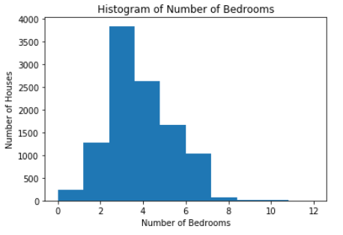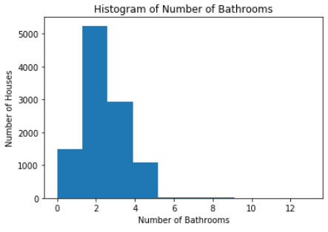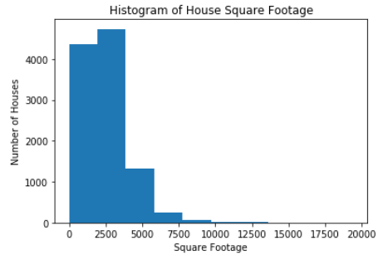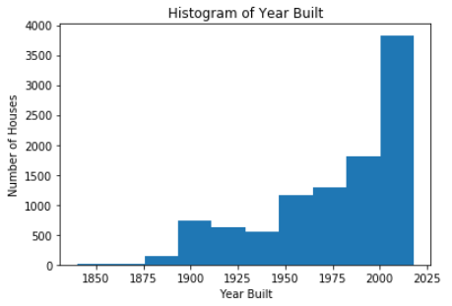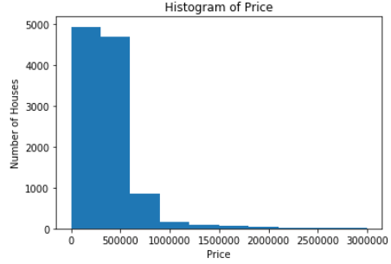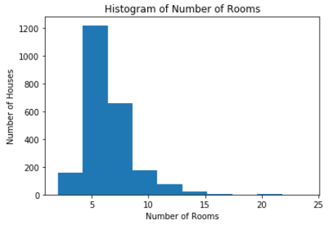

Number of rooms seems to have a normal and expected distribution, but you will notice that the scale for the number of houses is much smaller than the other distributions. This is because the KSL data did not include the number of rooms. But, these values are imputed later on, as the paper will discuss.

Acreage had a particularly interesting distribution. There is a very strong concentration of houses that have less than one acre, but there are also quite a number of houses that are higher than that. Below are two views of the acreage. On the left, the acreage distribution between 0 and 1 acre is shown. On the right, the distribution of 100 - 20,000 acres is shown.

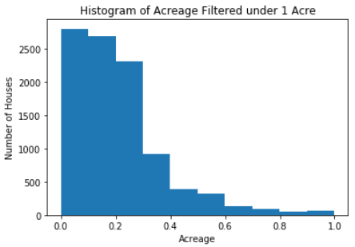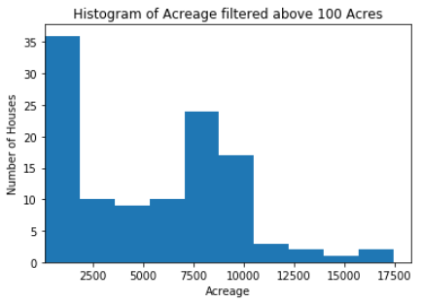

Of the common features between the two datasets, there were two features that we were unable to use: heating and cooling. These visualizations from the Zillow data in Pittsburgh show that over 50% of the data was missing from these. Unfortunately there was not enough information contained in the dataset to impute these values, so we chose to remove them.

**Heating** **Cooling**

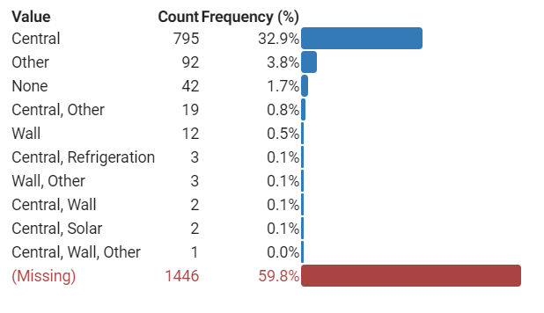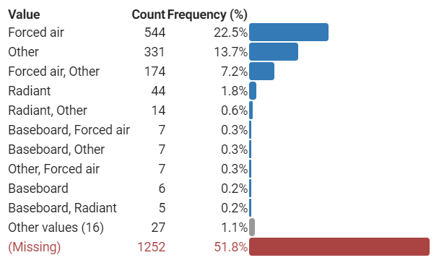

Some of the image and description data is missing: 540 images and 170 descriptions. In the cases where the image data was missing, these houses were dropped from the model. This did not affect the overall predictive power though because we were unable to train the full set of images. Where the description data was missing, it was replaced with padding data applied to all text, and would have had very low predictive power. We chose not to remove these from the model though with the assumption that no description could have a bearing on the price.

## Approach

#### How are others solving this problem?

House price predictions have always been a difficult problem to solve with high accuracy. There was even a Zillow Home Value Prediction Kaggle competition with a $1 million dollar prize. The competition provided numerical and categorical data for each listing. Some solutions to this competition used linear regression, boosted trees, and neural nets.

Zillow provides an overview on how their Zestimates are calculated:

“As with a human appraisal, the raw ingredients for a Zestimate are comparable sales as well. But instead of picking a few comps and trying to reconcile the differences between the target home and comparable homes, the Zestimate algorithm leverages its computing power advantage. Zestimate valuations are an average across hundreds of comparable sales. Like an appraiser, the Zestimate more heavily weighs homes that it judges as more similar to the target home. The weights assigned to each comparable sale are based on which home features minimize the difference between the algorithm’s value estimates of recently sold homes and the actual sale prices. The Zestimate is trying to build an optimal model of which facts about a home are important to buyers and thus can predict sale prices.”

Source: <https://www.zillow.com/data-science/human-and-machines-home-valuation/>

#### What methods did we consider to solve the problem?

We thought the numeric and categorical features would not be enough to accurately predict the price of a house. During a human appraisal of a house, the appraiser gets to see the house and other features that are not mentioned in the structured data fields from a house listing. Our approach is to include the main image of the house, as well as, the unstructured text description the owner provides of the house. We believe that including these additional features will uncover characteristics of the house that will allow us to more accurately predict the house price. Our initial thought was just to use images with the numeric features, but after reading through descriptions provided by the owners, we thought there would be valuable information, such as mentioning the house was recently renovated or it had new appliances installed.

### Data Cleaning

#### Data Imputation

Since our data came from two different sources, there were features that were not included in both sources.We decided to perform data imputation to keep features that we believe would be useful. An example of this is the “NumRooms” feature, which captures the total number of rooms a house has. Data from Zillow had this data for almost all listings, while KSL data did not have this feature at all. Based on Zillow data, we trained a linear regression model with the target at NumRooms and features as bedrooms, bathrooms, and square footage. Using this trained linear regression model, we predicted the NumRooms for all the KSL listings.

#### Removing Outliers

As to be expected with raw data, there were several outliers that we chose to handle in efforts to improve our modeling. The prices of homes ranged from $0 to $35.9 million. Certainly there is an error with a price of $0, and there are very few houses in the very high tens of millions range. To have houses that are more similar to each other we chose to remove all instances where the price was above $10 million or below $40,000.

Though KSL lists housing for sale in Utah, there are a few instances where houses in neighboring states are being sold. These were dropped as our assumptions are made in regards to housing in Pittsburgh and Utah. These were filtered out by using any latitude and longitude that were outside the state limits.

Besides numerical outliers, there were also outliers for some features because they were of a different type of data, namely, strings instead of numbers. A few examples of these: instead of a dollar amount, the price was listed as ‘False’; instead of a year, the year built was listed as ‘No Build Year Data’; instead of an acreage number, some were listed as ‘No Acreage Data’ or ‘False’.

#### Standardizing

A MinMaxScaler transformation from the sci-kit learn package was performed on the numerical features of the data. The MinMaxScaler is calculated by applying this formula for a data point x: **x**  - **xmin / (Xmax - Xmin).**

This will make all data points be between 0 and 1. Scaling features is important, so that the scale of large values, such as, year built, square footage, do not outweigh smaller scaled features like acreage, number of bedrooms, and number of bathroom.

### Feature Engineering

#### Clustering on Location

We felt that in order to more adequately predict a home’s price, we would need to create a more granular feature that described a home’s location. The idea stemmed from the belief that city limits and zip codes are not granular enough and that home prices can vary widely in the same zip code. Specific neighborhood data was not provided by the data sources and therefore we needed to compute this as a new feature.

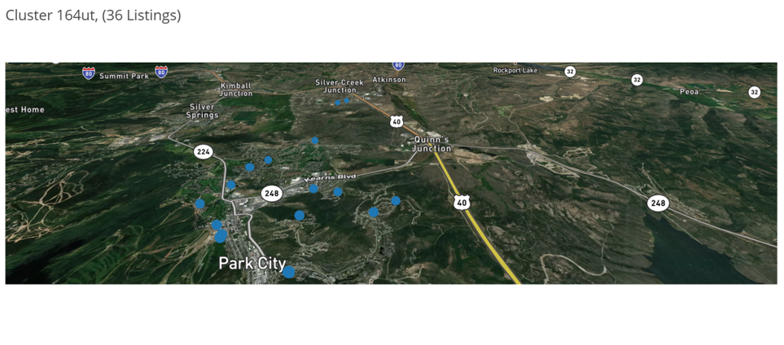

In an attempt to create more granular location clusters, we determined to use the kmeans clustering algorithm. We chose kmeans over other clustering algorithms such as a Gaussian Mixture Model because kmeans does not allow for overlapping clusters. Also, clusters are generally similar sizes in diameter. However, in order to create clusters at the neighborhood level we had to break free from the typical implementations of clustering algorithms like kmeans. For example, using the elbow method to determine the optimal number of clusters for all listings in Utah outputted a value of 20 clusters. Obviously this is far too few and would not provide the granular location data we desired. Instead, we arbitrarily selected a number for k which resulted in clusters that seemed to provide exactly what we wanted. Appendix B can be referenced to view screenshots of the clusters for all the data.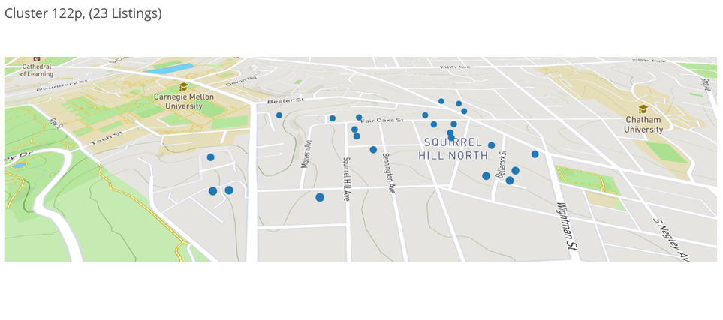

Upon completion of the cluster assignments, other location features including city, state, latitude, longitude, and zip code became obsolete. Because of this, we removed those features and only included the cluster assignments for use in our models to account for location.

#### Transforming Images

In order for images to be processed by our model, each image needed to be the same size. These images show examples of what images looked like before and after the transformation.

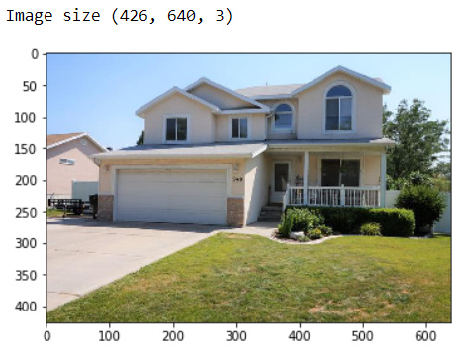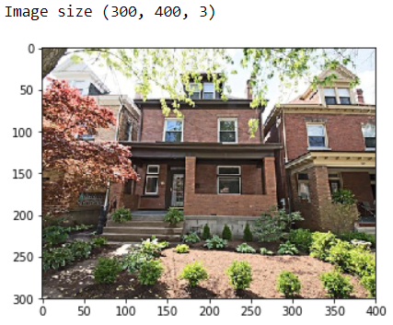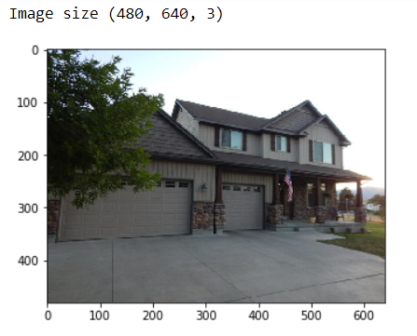 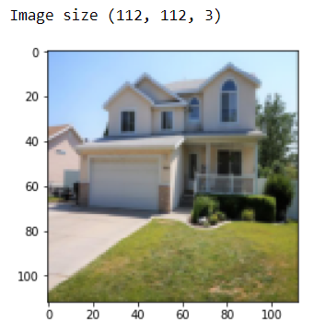 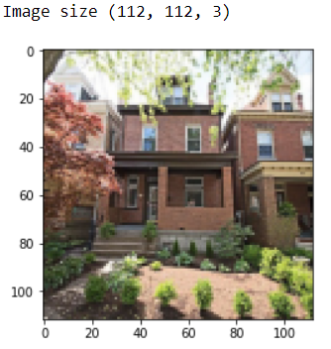 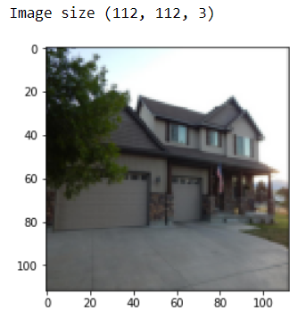

In order to speed up the processing power we chose a small image size (112x112) that would still hold enough information for our model to learn from. Because each image is a different size, the images are slightly distorted once transformed. We chose this method rather than cropping or padding, because we believe it preserves the information contained within the image the best. If an image were cropped portions of houses would be left out. If images were padded, then there would be large patches that contain no information about the house whatsoever.

#### Text Analysis

This piece of the project was assigned to Colton. In order to provide predictive power to the description text provided in the listings, we needed to lemmatize the text for further analysis. First, we imported the spacy package, loaded the English library, and disabled ‘ner’, ‘parser’, and ‘tagger’ because they were irrelevant to our analysis. We then iterated through each description and concatenated the text into one giant string. That string was then consumed by spacy into a variable we called ‘corpus_text.’ Each token (word) in ‘corpus_text’ was consumed through the spacy Natural Language Processing package which allowed us to group them by individual lemmas. We created a dictionary to count the number of words to see which words appeared most frequently. We also removed stop words. The top 20 most frequently occuring words are shown to the right.

From there, we tokenized each description using the keras.preprocessing.text package. Then, we converted the texts to sequences and padded those that had less than a maximum length of 200 and truncated those that were greater to create vectors of equal length for the Long-Short Term Memory (LSTM) model to consume in the embedding layer.

### Model Creation

Five different models were analyzed using mean squared error (MSE) as the performance metric. We created a baseline model, so we can compare the results of our more advanced models. We used the same transformed dataset for all models with the applicable features for each model. Neural net models were tuned with different optimizers, activation functions, and layer architecture. The best optimizer across all neural nets was the adam optimizer. The performance of different activation functions varied across neural nets and each layer. Due to being a regression problem, not many activation functions that squeeze weights down to low values (ex. Sigmoid, softmax) were used. Better performance was seen with linear and relu activations.

#### Baseline Model (Linear Regression) with Numerical Features Only

We created a baseline model using linear regression with scaled numeric features. We trained a baseline model, so we can compare the results of our more advanced models. We used the same transformed dataset for all models with the applicable features for each model.

We used sci-kit learn package to train linear regression on the training data that included the numeric and one-hot encoded features.

The resulting mean squared error was 0.02159. This will be the baseline measure for assessment against other models.

#### Multi-Layer Perceptron (MLP) with Numerical Features Only

We created a MLP neural net using the same numeric only features as the linear regression model. The MLP was implemented using Keras TensorFlow package. The model we created had an input layer, 3 hidden layers, and an output layer with one neuron, which represents the predicted house prices. Multiple activation functions were attempted with the best combination being:

* Input layer: linear activation
* Hidden layer 1: linear activation
* Hidden layer 2: relu activation
* Hidden layer 3: sigmoid activation

The output layer requires a single neuron with a linear activation, since this is a regression problem and we want to predict a single output for the price of the house.

Neural Net Architecture

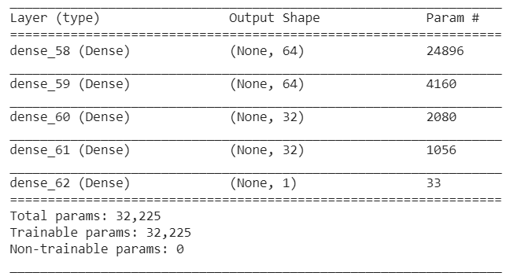

The plot below shows the training and validation error, there is a large drop in errors around 15 epochs. We have tried up to 100 epochs, but there seemed to be a overfitting problem over 30 epochs since the validation error began to increase further. 30 epochs was the optimal number of epochs for this data.

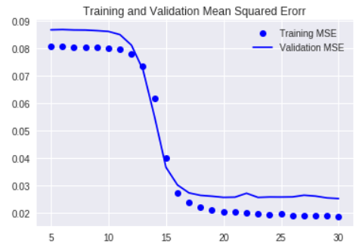

#### Convolutional Neural Net (CNN) with Images Only

To train on the house images only, we decided to use transfer learning with the VGG-19 model. VGG-19 is a pretrained model from tensornets, pre-trained on 1.2million labeled images from imagenet. The first 17 layers were frozen and weights were not updated with our training data. The last 5 layers of the VGG-19 were trainable in addition to the 5 additional new layers appended to the end of the VGG-19 model. Having these layers trainable allows us to learn weights specific to our prediction task.hA dropout layer was added to help prevent overfitting. The dropout layer randomly sets some weights to zero, which increase train error, but should help the model generalize better. See appendix C for full architecture.

Initially we scaled all image sizes to (224, 224, 3) to train this model. After issues with the GPU, we further scaled the images to (112, 112, 3) to speed up the training time for the model.

The following graph shows the training and validation error. The error for the first epoch was left out because the error was very high and made it difficult to see the error change in future epochs.

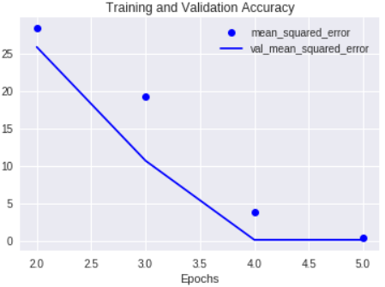

Here are examples of good pictures of houses that we believe the model will help the model learn weights.

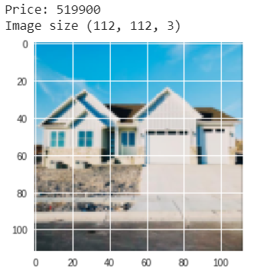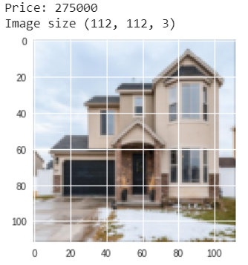

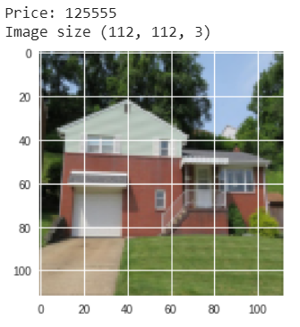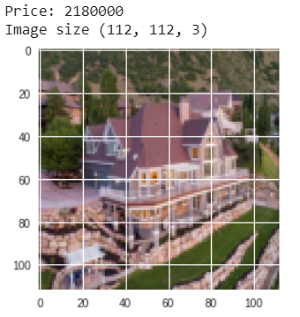

Here are some bad images that listings had as their main photo, we believe that this negatively affects the model performance because from looking at these pics ourselves, it’s hard to tell what price these houses would be.

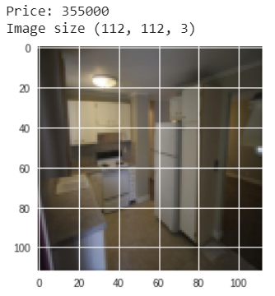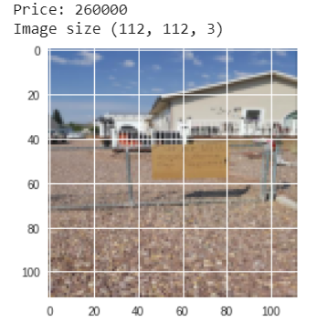

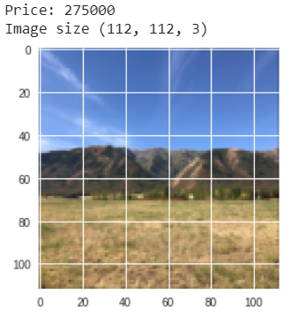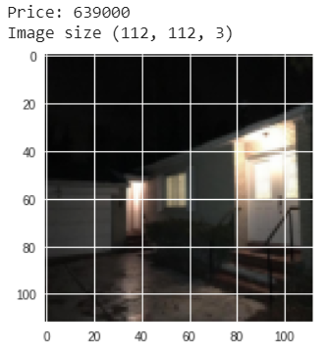

#### Long-Short Term Memory (LSTM) with Text Descriptions Only

To learn from the unstructured text descriptions, we decided to use a LSTM model to preserve some of the sequence of words. Most descriptions contain words that are more meaningful together rather than a bag of words approach. For example, some descriptions mentioned “renovated kitchen”, “formal dining room”, “game room”, etc. We believe the model will learn these word associations to better predict the price of a home.

Our model included a beginning embedding layer, a 64 neuron dense layer, and a final single neuron output layer with linear activation. The model was compiled using the adam optimizer and calculated loss based on mean squared error. This was used to see how well the model could predict price if we only predicted using the listing description. This model also had a dropout layer because after just a few epochs the validation error started to increase while the training error continued to decrease. After adding the dropout layer, the validation was lower than the train error and somewhat consistent.

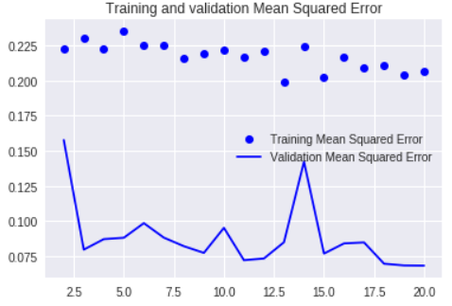

#### Mixed -Type Multi-Input Neural Network with all feature types

After training each neural net with each type of data (structured numeric, images, unstructured text) separately, we combined the three neural nets into a combined mixed-type multi-input neural net. Each neural net on it’s own may not be enough to give the most accurate predictions. Using this combined neural net, the weights learned from each type of data can be combined and tuned to reduce mean squared error of house price predictions. See appendix d for the full architecture.

To create the combined neural net, the separate neural nets were used, but the single neuron output layer from each model was removed and replaced with the 32 neuron fully connected dense layer. These dense layers were concatenated into one layer. Another fully connected dense layer was added after the combined layer to help learn the importance of each weight. A final single neuron output layer with a linear activation was added to predict the house price. This neural net has a total of 25,723,153 parameters, which of these 12,778,193 were trainable parameters. The other remaining parameters were frozen from the VGG-19 model.

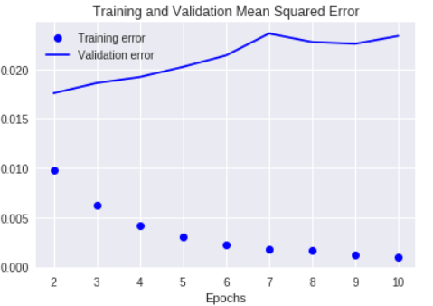

## Results

### Model Performance

The models were evaluated based on mean square error (MSE). The mean squared error represents the squared difference of the predicted and actual log10 of the sales prices.

The linear regression model actually performed well. The MLP model with the same features performed similar to the linear regression model. This may indicate that the data is nearly linearly correlated and does not need to learn a complex distribution that a neural net would be able learn.

Each the CNN and LSTM models trained only on images and text descriptions performed worse than linear regression. This is may be because we did not include the numeric features (ex. Bedrooms, bathrooms, square footage, etc.) which are strongly correlated with the house price. The CNN model with images performed the worst, most likely because of the type and quality of images. We used the main photo posted in a listing assuming that the picture would be of the front of the house. We saw that many pictures we either of the interior of the house or images with obstructed views of the house. We believe that this added noise to the model and did not enable it to learn how a picture of a house correlates with the price.

The MSE from the combined performed better than each of the separate neural nets and also slightly performed better than our baseline linear regression. Since the combined neural net performed better than the 3 separate neural nets, this shows that using all data types together improves performance. If we are able to better clean the images and do more natural language processing on the unstructured text to reduce the errors of those models, the combined neural net error would most likely decrease.

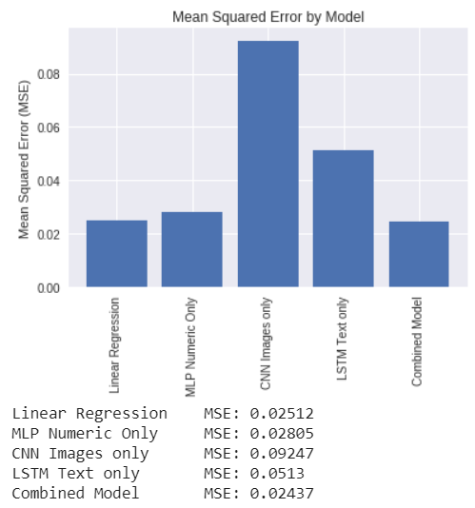

### A Personal Test

We used images from Colton’s home in Pittsburgh as well as his home he recently sold in Layton, Utah. We wanted to test to see how much a good or bad description would help in predicting along with different images from the homes. We tried four from the Layton home, and two from the Pittsburgh home. The combinations were as follows:

**Pittsburgh, PA (Greenfield)**

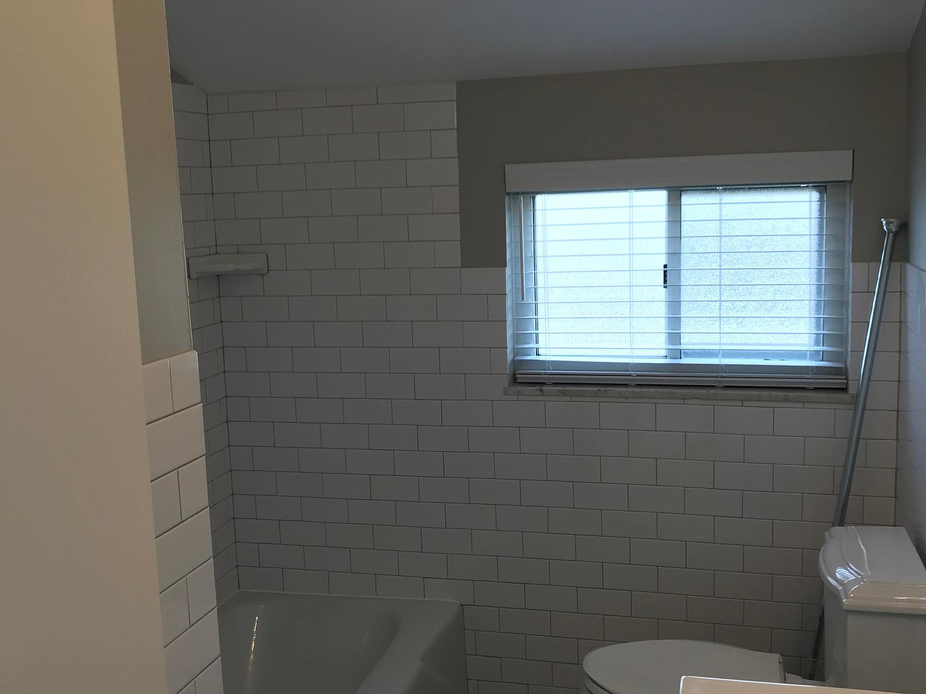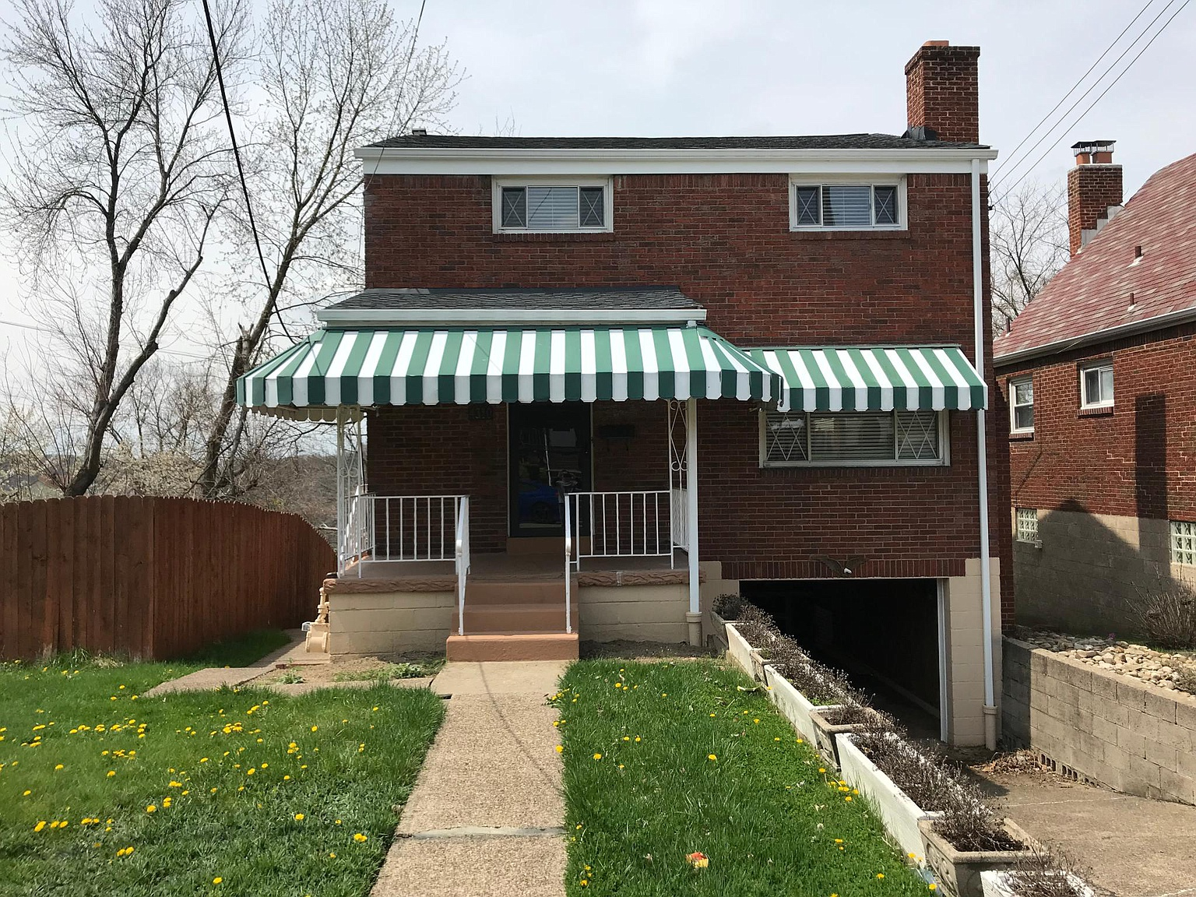

**Good Description**: *Awesome location! Very close to Carnegie Mellon University shuttle stop. Quiet neighborhood with great neighbors. Granite countertops. Stainless steel appliances. Newly renovated. Brand new, updated bathroom. Fireplace. Updated AC and Heat. Awesome view of downtown. Picnic table and porch overlooks nearby park and baseball field.*

**Poor Description** (This was the description provided on Zillow by the landlord): *Great location Updated Great back yard and deck On and off street parking with new garage door opener Tenant pays all utilities*

**Layton, Utah**

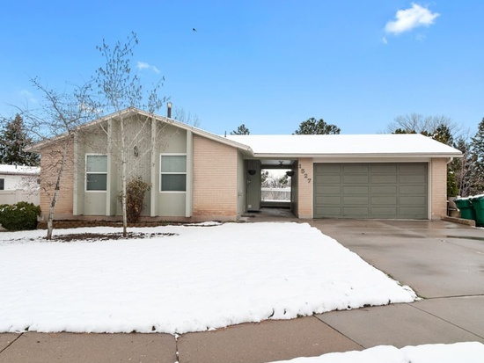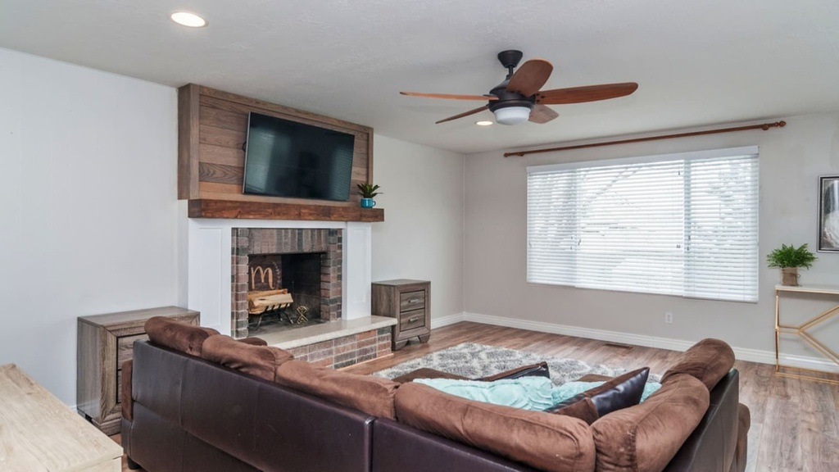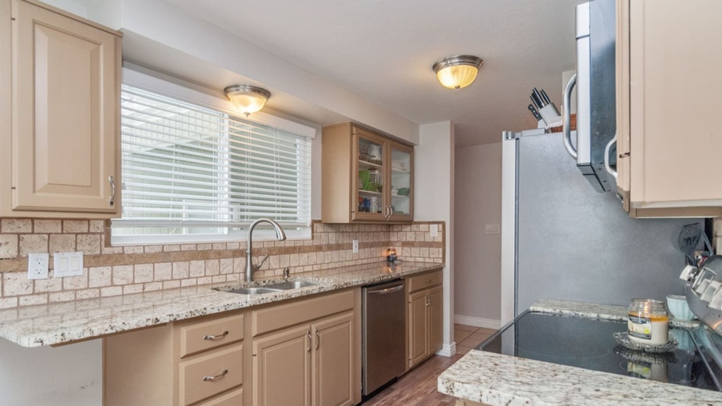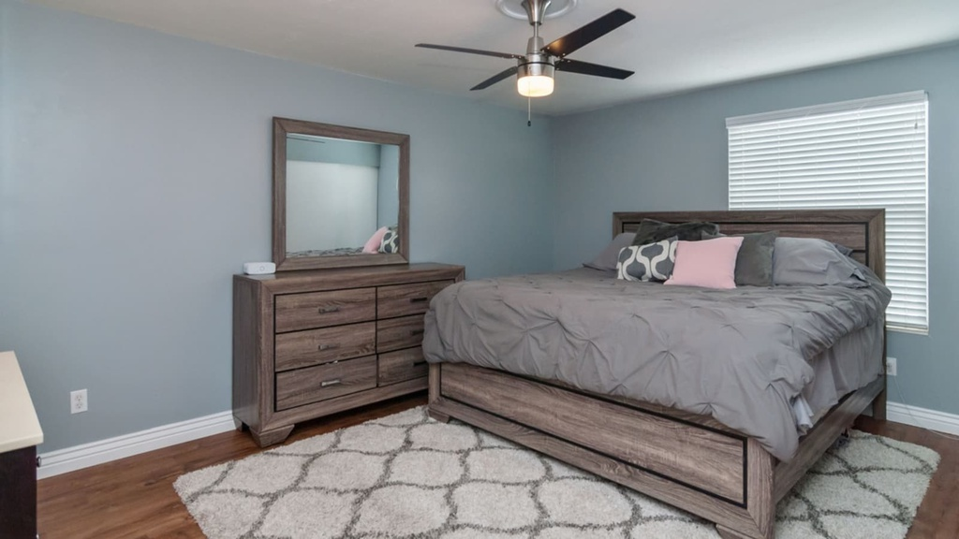

**Good Description**: *Still accepting tours! Beautiful, updated rambler home with basement apartment! Upstairs kitchen has granite counter tops, updated gorgeous fireplace, wooden floors, 3 bedrooms and 2 baths. Downstairs is a basement apartment with a separate walk-out entrance, 2 bedrooms and 1 bath. The basement kitchen has updated cabinets and appliances. Downstairs bedroom has spacious walk-in closet. Separate from the possible basement apartment is the large laundry room with great storage space.*

**Poor Description** (This was made up to test negative semantic wording): *Neighbors weren't great. We suspected our neighbors were drug dealers. High crime. Bad landscaping from north neighbor.*

The results were quite interesting. We tested each model. First, only including the numeric data. Second, only the images. Third, only including the text descriptions. Lastly, we combined all three and predicted again. Here are the results:

|  |  |  |  |  |  |  |
| --- | --- | --- | --- | --- | --- | --- |
| **Photo** | **Description** | **Numeric Only** | **Image Only** | **Description Only** | **Combined Models** | **Actual Zestimate** |
| Pittsburgh, Bathroom | Good | $230,113.35 | $147,009.86 | $248,178.38 | $223,382.47 | $111,204 |
| Pittsburgh, Bathroom | Bad | $230,113.35 | $147,009.86 | $133,501.13 | $159,381.14 | $111,204 |
| Pittsburgh, Front | Good | $230,113.35 | $259,464.10 | $248,178.38 | $223,382.47 | $111,204 |
| Pittsburgh, Front | Bad | $230,113.35 | $259,464.10 | $133,501.13 | $159,381.14 | $111,204 |
| Layton, Front of Home | Good | $397,676.33 | $195,421.02 | $324,642.57 | $404,007.59 | $411,500 |
| Layton, Front of Home | Bad | $397,676.33 | $195,421.02 | $259,776.81 | $401,922.82 | $411,500 |
| Layton, Family Room | Good | $397,676.33 | $169,972.86 | $324,642.57 | $404,007.59 | $411,500 |
| Layton, Family Room | Bad | $397,676.33 | $169,972.86 | $259,776.81 | $401,922.82 | $411,500 |
| Layton, Kitchen | Good | $397,676.33 | $92,835.04 | $324,642.57 | $404,007.59 | $411,500 |
| Layton, Kitchen | Bad | $397,676.33 | $92,835.04 | $259,776.81 | $401,922.82 | $411,500 |
| Layton, Master Bed | Good | $397,676.33 | $102,032.61 | $324,642.57 | $404,007.59 | $411,500 |
| Layton, Master Bed | Bad | $397,676.33 | $102,032.61 | $259,776.81 | $401,922.82 | $411,500 |

The predictions for the Pittsburgh home seem extremely inaccurate compared to the Zestimate. Here is why. The landlord purchased the home in June 2018 for an incredible price of $100,000 from his grandmother. At the time, the Zestimate was over $190,000 and seemed to be projecting upward. The Zestimate was re-calibrated to account for the purchase and is now much lower. Here is a graph showing the home Zestimate over the course of the last decade.

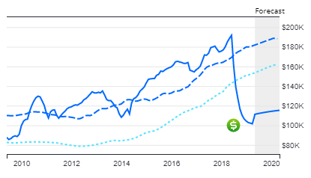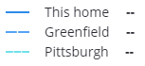

### How can we improve?

One way we felt we could improve is by including more images besides just the main image from a listing. We believe it would help to be able to classify certain images at specific rooms from a house (e.g. kitchen, bathrooms, bedrooms, master, den, dining room, etc.) and then use those new features to further predict the price. In researching what Zillow does to predict their Zestimate, it seems that they do something similar with all the images that a user includes on a listing. Using a semi-supervised method by manually labeling some images with the type of picture it is, we can using a neural net to predict the label for the unlabeled pictures.

### What did we learn?

For starters, much of our time was spent generating data and then cleaning the data. We knew going in that this would be where a large chunk of our time was spent but we didn’t anticipate it being as much as it was. We also learned that sometimes the simplest models are best in the real world. If you don’t need to reinvent the wheel and train a computationally expensive neural network because a linear regression does well, then go with the simpler linear regression model.

Another important item that was nice to learn was how to combine different neural networks into a single model and predict on what was trained from each of the previous models. We deemed this a ‘Mixed-Type Multi-Input Neural Network’ and described this in more detail in the Model Training section above.

Lastly, we had issues with our GPU when training our models. It wasn’t that it was taking too much time or even that it was too computationally expensive. It was that Google Colab failed to initialize our convolution network and we needed to somehow connect via a cuDNN to get it to work. We spent countless hours trying to reinstall and upgrade Tensorflow and Tensorflow-gpu with no luck. We created an issue on the google collab github. We tried AWS, but then had further issues with other packages. Oddly, the model worked just fine for about a week but then suddenly would not allow us to train past the chunk of code where the photos were running through the neural network.

## 

## Appendix

### Appendix A - Links to Google Colab .ipynb Files

KSL Data Generation: <https://colab.research.google.com/drive/1MwTYPPk2upDwG5E41piHod7bkSH_kPFX>

Zillow API and data generation: <https://drive.google.com/open?id=137PhOTZGAbIa7iUYTBeF6DdjsPgtIYZU>

Exploratory Data Analysis: <https://drive.google.com/open?id=17wKHpgZtnsT1OMuGhusrU6mMT8KfARGr>

Clustering: <https://drive.google.com/open?id=1uPFh6-UC1dIl_rsU2T3mk0Pcma5piDmv>

Imputation/Model Training: <https://drive.google.com/open?id=1dbYJQwU1WTChucSQcfh6nmtUA_JMS-CN>

Image Retrieval: [https://colab.research.google.com/drive/1QWnXvQsLC6rAifv7T7Y1xu1BJdGJVDQG](https://colab.research.google.com/drive/1QWnXvQsLC6rAifv7T7Y1xu1BJdGJVDQG?authuser=1#scrollTo=eBuoWEoeN1ts)

Image Transformation: [https://colab.research.google.com/drive/1Ec8fq9NIg8OM_3vKl5Oo3EfygTZy1cuK](https://colab.research.google.com/drive/1Ec8fq9NIg8OM_3vKl5Oo3EfygTZy1cuK?authuser=1#scrollTo=ZNpiT8rBNQqJ)

### Appendix B - Clustering locations with latitude and longitude

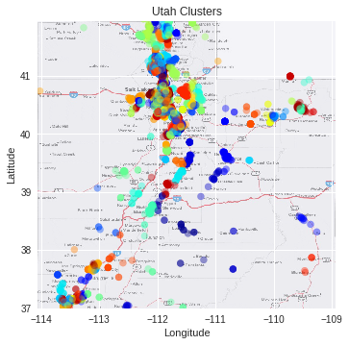

### 

### 

### Appendix C - CNN Model Architecture

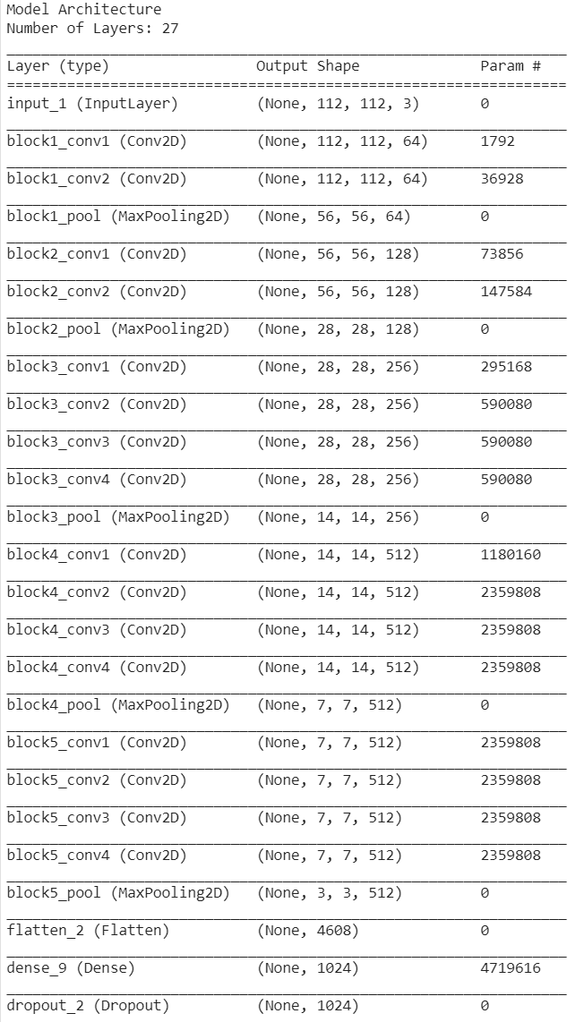

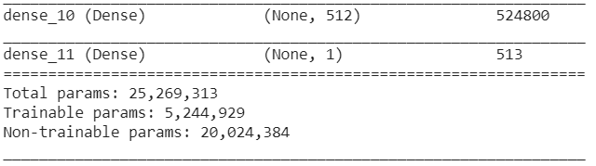

### Appendix D - Combined Neural Net Architecture

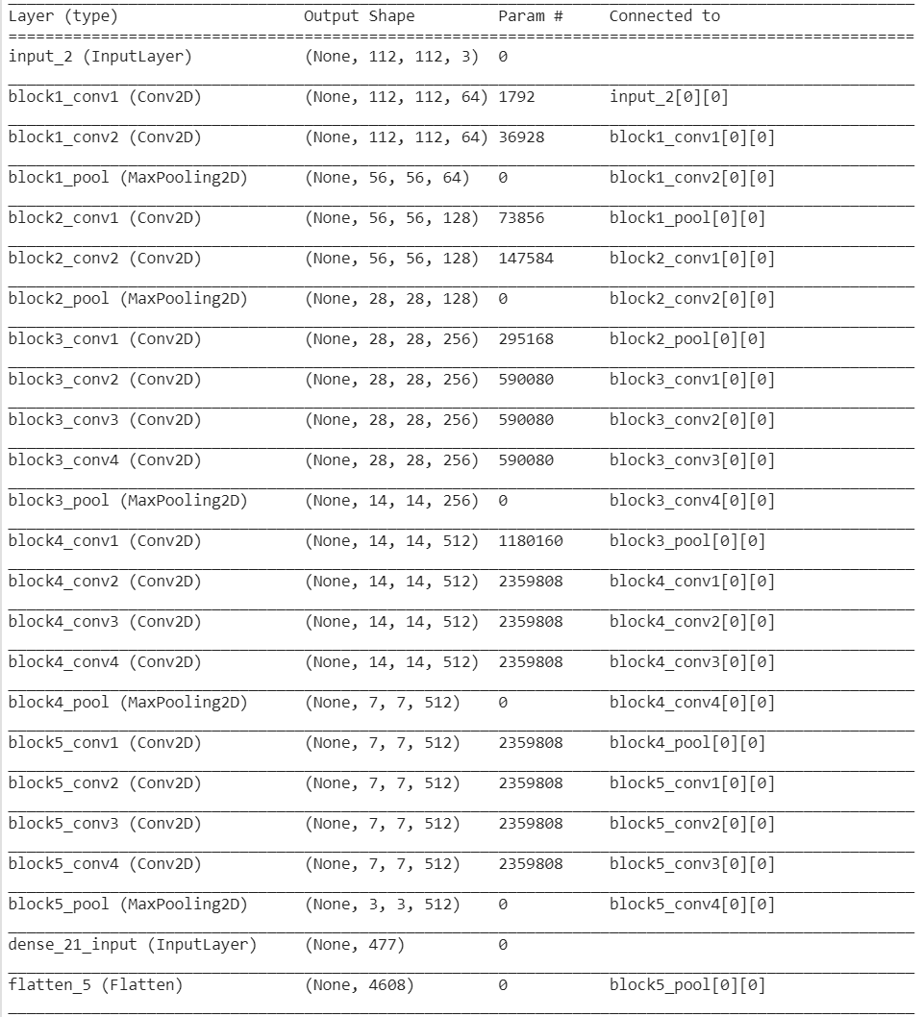

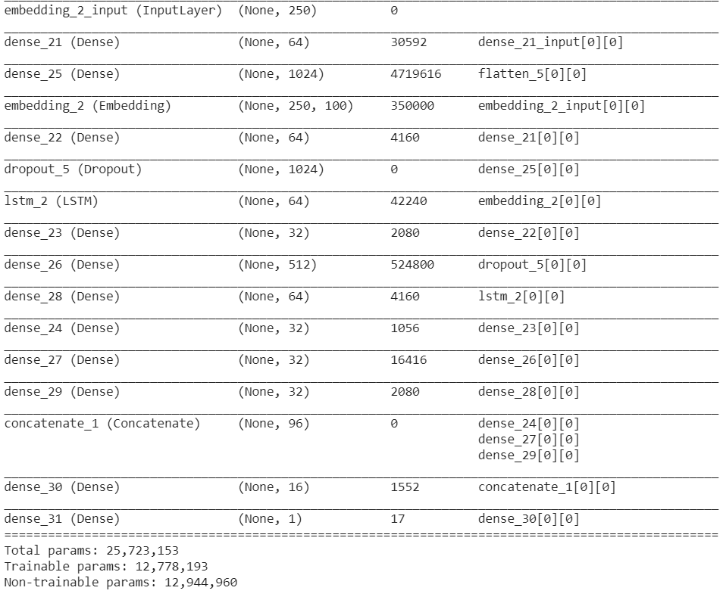

References

* Zillow API documentation: <https://www.zillow.com/howto/api/APIOverview.htm>
* Pre-trained VGG-19 Imagenet mode: <https://github.com/keras-team/keras-applications/blob/master/keras_applications/vgg19.py>

### Appendix E - Team Member Assignments

Colton Mouritsen: KSL data generation and cleaning. Clustering based on latitude and longitude. Text analysis and neural net creation and training for text data.

Alex Caico: Zillow API calls, data imputation for null values, data transformation (standardization), models creation, training, and testing.

Nicolas Wells: Data preprocessing and combining, Image Retrieval, Image Transformation, Outline for Slideshow, Outline for paper.